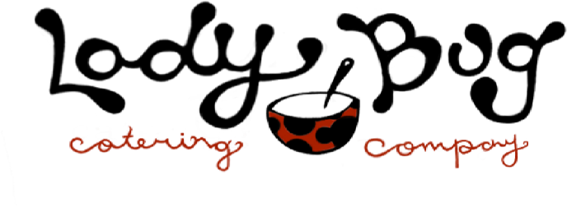
DEC PRESCHOOL HOT LUNCH:

Date Lunch Student Name(s) Grade
12/2 French Toast Sticks ______________________________ _______
(bacon or sausage) ______________________________ _______
12/4 Bag Lunch Option ______________________________ ___Full Day Students
*Turkey/Ham Sub or Crackers/Cheese/Salami, Applesauce, Carrots, Go-Gurt, Chips and Dessert
12/5 Chicken Nuggets ______________________________ _______
(w/side mac & cheese) ______________________________ _______
12/6 Hamburger/Cheeseburger ______________________________ _______
w/french fries ______________________________ _______
12/9 Spaghetti w/Meat Sauce ______________________________ _______
or buttered noodles ______________________________ _______
12/11 Mac & Cheese ______________________________ _______
(w/sliced hot dog on side) _____________________________ _______
12/12 Fett. Alfredo w/Chx side ______________________________ _______
(or buttered noodles) ______________________________ _______
12/13 Popcorn Chicken ______________________________ _______
(w/sweet corn & pretzels) ______________________________ _______
12/16 Waffles ______________________________ _______
(bacon or sausage) ______________________________ _______
12/18 Nachos (beef on side) ______________________________ _______
(or Quesadilla – w/rice and beans) ______________________________ _______
12/19 Chicken Nuggets ______________________________ _______
(fries or tots) ______________________________ _______

Lunches $4.00 x ______ = ______
Total: _______

Please make checks payable to Ladybug Catering / VENMO ladybugcatering-2017
Questions? E-mail Shannon Carr at ladybugcatering@yahoo.com or call 425-248-8833. Merry Christmas. Thanks

