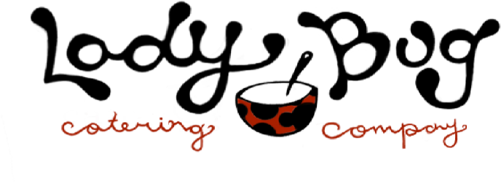
JAN PRESCHOOL HOT LUNCH:
Date Lunch Student Name(s) Grade
1/6 Chicken Nuggets ______________________________ _______
Fries & Tots ______________________________ _______
1/8 Spaghetti w/Meatballs ______________________________ _______
or buttered noodles ______________________________ _______ 1/9 Chicken Teriyaki ______________________________ _______
w/Fried or White Rice ______________________________ _______
1/10 Nachos (beef on side) ______________________________ _______
(or Quesadilla – w/rice and beans) ______________________________ _______
1/13 Hamburger/Cheeseburger ______________________________ _______
w/French Fries ______________________________ _______
1/15 Bag Lunch Option ______________________________ ___FULL DAY STUDENTS
*Turkey/Ham Sub or Crackers/Cheese/Salami, Applesauce, Carrots, Go-Gurt, Chips and Dessert
1/16 Fett. Alfredo w/Chx side ______________________________ _______
(or buttered noodles) ______________________________ _______
1/17 French Toast & Hashbrown ______________________________ _______
w/Bacon or Sausage _____________________________ _______
1/22 Meatball Sub ______________________________ _______
or Buttered Noodles ______________________________ _______
1/23 Popcorn Chicken ______________________________ _______
w/sweet corn & pretzels ______________________________ _______
1/24 Mac N’ Cheese w/Hot Dogs ______________________________ _______
1/27 Waffles & Hashbrown ______________________________ _______
w/bacon or sausage ______________________________ _______
1/29 Beef Soft Taco ______________________________ _______
or Quesadilla w/rice & Beans ______________________________ _______ 1/30 Chicken Eggrolls ______________________________ _______
w/Rice ad Edamame ______________________________ _______
1/31 Chicken Nuggets w/Mac N’ Cheese ______________________________ _______
Lunches $4.00 x ______ = ______
Total: _______
Checks payable to Ladybug Catering / VENMO ladybugcatering-2017 - Shannon Carr ladybugcatering@yahoo.com

